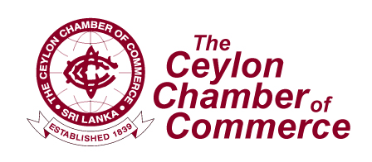

“CCC BSM 2010”
INTERNATIONAL BUYER/SELLER MEET – OCTOBER 29, 2010

Greetings from the Ceylon Chamber of Commerce (CCC), the premiere Chamber in Sri Lanka!

The CCC in its effort to promote Trade, Investment, Services & Joint Ventures, will be organizing an International Buyer Seller Meet – “CCC BSM 2010” in Colombo, in partnership with the Ministry of External Affairs, the Sri Lanka Export Development Board (EDB) and the Department of Commerce of Sri Lanka. This will coincide with the International Catalogue Exhibition organized at the same venue.

Venue: Taj Samudra - Colombo
Date & Time: - October 29, 2010 from 08.30 a.m. – 05.00 p.m.

The “CCC BSM 2010” will…..

- Provide a platform for over 75 overseas & 100 Sri Lankan enterprises to network

- Offer an Opportunity to Interact & Establish Contacts Globally

- Facilitate links with prospective Business Partners

- Create opportunities to establish new links and expand existing contacts

- Assist in setting up strategic partnerships and expansion of Trade & Investment

Generate opportunities for Transfer of Technology and tie-up/negotiate Joint Venture Proposals

Shehan Hettige
Management Executive
Foreign Trade and Information Department
The Ceylon Chamber of Commerce
50, Navam Mawatha,
Colombo 02
Sri Lanka.
Tel: +94 11 5588869
Fax: +94 11 2381012
Web: www.chamber.lk


