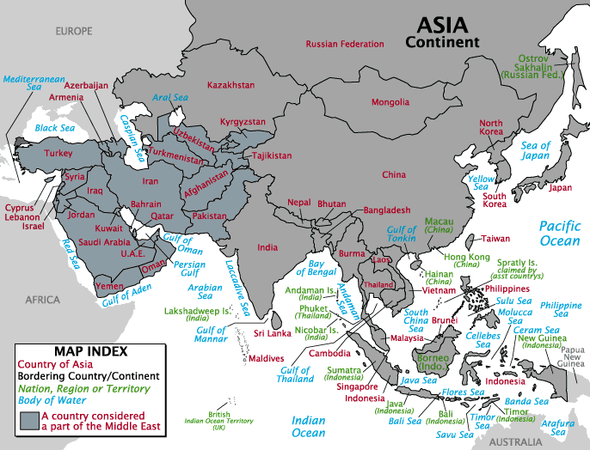
KYRGYZSTAN
Location

General information
Capital city | Bishkek
Population | 5.3 mln. people
Area | 199,9 thousand km2
Climate | Dry, Continental
Head of State | President
Head of Government | Prime Minister
Currency | Som (as of July, 2009 1$ ≈ 43 som)  freely convertible

The Kyrgyz Republic Overview
The Kyrgyz Republic is a country of exceptional natural beauty and proud nomadic traditions, with a fast-growing economy and a broad range of investment opportunities. It is a mountainous, landlocked nation in Central Asia with a population of 5.3 million people. The country is home to one of the jewels of Central Asia - the Lake Issyk Kul, which means “warm lake” in the Kyrgyz language. It never freezes, and is the second largest mountain lake in the world, after Lake Titicaca in South America. The lake is surrounded by the snow-capped peaks of the Tian Shan Mountains.
The population of Kyrgyz republic is made up of Kyrgyz (64.9%), Uzbeks (13.8%), Russians (12.5%), Dungans (1.1%), Ukrainians (1%), Uygurs (1%) and others (5.7%). Islam is the largest religion in the country (75%), with a sizable Russian Orthodox presence (20%). The official languages are Kyrgyz and Russian. It is a tolerant country where all religious and ethnic groups live in peace and harmony.
The constitution defines the country as a democratic republic. The parliament currently is unicameral. The judicial branch comprises a Supreme Court, a Constitutional Court, local courts and a Chief Prosecutor. The country has a vibrant community of non-governmental organizations (NGOs).
In December 1998 Kyrgyz republic was the first Commonwealth of Independent States (CIS) country to be accepted into the World Trade Organization (WTO). After a brief period of political uncertainty in March 2005, Kyrgyz republic went on to develop rapidly in both the political and economic spheres and is carrying out sweeping economic and social reforms.
A centrally located country, the Kyrgyz Republic borders China, Tajikistan, Uzbekistan and Kazakhstan. The Government successfully develops good relations with all its neighbors and promotes regional cooperation. Besides the Commonwealth of Independent States (CIS), the Kyrgyz Republic is an active member of various regional security and economic organizations, ranging from the Shanghai Cooperation Organization (SCO) to regional economic groupings such as the Eurasian Economic Community.
The country strives to balance its international relationships. Regionally, Russia and the other CIS countries remain key partners. Kazakhstan is an extremely important neighbor for Kyrgyz republic, allowing for the transit of Kyrgyz exports of agricultural and other products. Kazakhstan is also a key foreign direct investor, especially in the banking sector. China is another significant trading partner and the third largest destination for exports (after the United Arab Emirates and Russia), as well as the third largest provider of imports. China is also an important source of bilateral financial support. Recently, it provided financing to complete a section of a road linking China to Uzbekistan through the Kyrgyz Republic.
GDP grew 8.2% in 2007, due to a better business environment. The economy is expected to grow 7.0% for 2008, and 6.5% for 2009. GDP growth slowed to 7.1% in the first half of 2008 from 8.8% in the same period the previous year, reflecting spillovers from neighboring Kazakhstan through the trade, investment, and remittance channels.
Culture
The Kyrgyz were traditionally nomads, who originally came from Siberia and then moved to what today is Kyrgyzstan. Kyrgyz culture has been greatly influenced by their nomadic heritage. It is reflected in the way a household was run, in customs and rites. People decorated their homes with items that were both beautiful and practical. The masterpiece of folk creation is the Kyrgyz yurt (yourt, yurta, tent), which was easy to assemble and transport from place to place.
Horse-back riding is one of the most important parts of Kyrgyz culture, and a Kyrgyz saying even says: "If you would have only one day to live, you should spend at least half of it in the saddle." An abundance of horse-back riding games exist, which are often presented with festivals or shows, and the perfection of the Kyrgyz in their saddle.
Traditionally, children used to learn how to ride a horse when they just start walking. Girls, on the other hand, learned traditional handicraft, creating beautiful carpets. The most famous carpets are shyrdak and ala-kiyiz, which are both made from sheep’s felt and shows geometric patterns seen in nature.
The symbol of the Kyrgyz life is the yurt. Until the country’s industrialization in 1920s a yurt was the home of choice for many Kyrgyz. The top of the yurt has an opening for smoke and fresh air, and is represented in the country’s flag. The Kyrgyz flag is red and round in the centre, symbolically showing the tyunduk - the central part of the yurts roof.
The yurt is a multifunctional, portable home, consisting of a wooden construction and the felt covers. The whole structure is fixed with short leather-ribbons (instead of nails) and ropes made from animals hair.
Besides the yurt, another very important part of Kyrgyz culture and pride is national folk hero Manas. The epos that has been named after him and consists of three parts, tells the story of the hero Manas and his son and grandson, in the 10 th century. He has been born in the region of Talas, in the north-west of the country, and it is said that at the age of 9, he already defeated the snake with wings - the scene can be watched in Bishkek in form of a statue at the place in front of the Philharmonia.
The epos, which is longer than the Odyssey and Iliad together, has been passed on orally from generation to generation over millennia, and the first written version appeared only in 1920s.
The storytellers and -singers who were able to sing this important masterpiece were highly honored and respected, they were called "Manaschi".

Rankings
The Economic Freedom of the World report seeks to measure the consistency of the institutions and policies of various countries with voluntary exchange and the other dimensions of economic freedom. Every year it ranks 143 countries for economic freedom by five major categories. Since its inclusion in the rankings in 2007 Kyrgyzstan performed relatively well. In the latest 2008 edition Kyrgyzstan progressed from 68th to 60th, that tracks Kyrgyzstan progress up to 2006. The next report is expected in October 2009.
Both Kyrgyzstan and Kazakhstan received high marks for the size of government and access to sound money. Government consumption as a percentage of GDP was 16.33% in the Kyrgyz Rep., while 18.32% in Kazakhstan. The passage of a flat 10% corporate and income tax as well as sector-wide cuts in civil servants in the Kyrgyz Rep. likely caused such progress. The Kyrgyz Rep. improved in Access to Sound Money category for keeping inflation within five percent the last five years, while oil-drive growth in Kazakhstan has initiated inflation. Although, Kyrgyz Rep. received a low mark for capital controls, 5.00, Kazakhstan received 1.54.
Kyrgyzstan
Category | 2005 | 2006
Overall Rank | 68 | 60
Size of government | 7.93 | 8.05
Legal structure and security of property rights | 3.73 | 4.61
Access of sound money | 8.65 | 8.69
Freedom to trade internationally | 6.55 | 6.78
Regulation of credit, labor and business | 6.76 | 6.68

The Heritage Foundation’s Index of Economic Freedom that measures economic freedom by slightly different parameters and different terminology. It rated Kyrgyzstan 61.1% free and ranked it 70th freest country in the world, ahead of Kazakhstan and far ahead of Russia. Kyrgyzstan’s strong points are trade freedom, as evidenced by size of Dordoi, the largest market in Central Asia, Freedom from Government, due to the 10% corporate and income tax rate and monetary freedom, due to a long history of ~4% inflation, until the end-2007.

Kyrgyzstan
Business Freedom | 60
Trade Freedom | 81
Freedom from Government | 94
Monetary Freedom | 76
Investment Freedom | 50
Financial Freedom | 50
Property Rights | 30
Labor Freedom | 72

Kyrgyzstan’s ranking by Doing Business.
Ease of... | Doing Business 2009 rank | Doing Business 2008 rank | Change in rank
Doing Business | 68 | 99 | +31
Starting a Business | 31 | 50 | +19
Dealing with Construction Permits | 58 | 170 | +112
Employing Workers | 81 | 80 | -1
Registering Property | 52 | 54 | +2
Getting Credit | 28 | 25 | -3
Protecting Investors | 11 | 33 | +22
Paying Taxes | 155 | 152 | -3
Trading Across Borders | 181 | 180 | -1
Enforcing Contracts | 52 | 51 | -1
Closing a Business | 137 | 131 | -6

Note: Doing Business 2008 rankings have been recalculated to reflect changes to the methodology and the addition of three new countries.
Source:
- Ministry of Economic Development and Trade of the Kyrgyz Republic
- World Bank’s Doing Business Report, 2009
- www.bialeco.com
- www.k-a.kg
- www.ibc.kg
- www.investinkg.com

